EXPERIMENT 7

Create table bank_exp7(bankname varchar(30), headoffice varchar(30), branch int, branchcode varchar(30) primary key);
- COMMIT
insert into bank_exp7 values('SBI BANK','DELHI',30,'SBI');
COMMIT;
insert into bank_exp7 values('CANARA BANK','ERNAKULAM',20,'CNB');
COMMIT;
insert into bank_exp7 values('SOUTH INDIAN BANK','MADRAS',30,'SIB');
COMMIT;
- SAVEPOINT
insert into bank_exp7 values('ICL FINCROP','ERNAKULAM',10,'ICL');

insert into bank_exp7 values('BOOTHOUSE BANK','PALAI',2,'BHB');

SELECT * FROM BANK_EXP7;
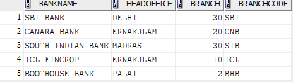

- ROLLBACK
ROLLBACK TO S1;
SELECT * FROM BANK_EXP7;
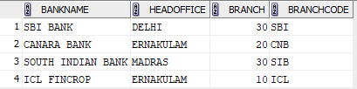

GRANT

REVOKE

